 | 14.3.5 Editors - Video Sequence Editor - Sidebar - Sequencer - Cache tab
Table of content
Cache Settings panel 1
Display Cache 1
Final 1

Cache Settings panel
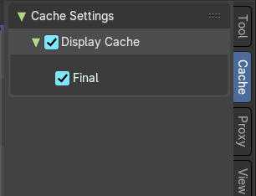
The Cache is used to save frames in memory for preview, so they can be later displayed much faster than rendered from scratch. Cache capacity can be set in System tab of the Preferences.
In this panel you can set up types of images that will be cached for all strips.


Display Cache
This displays the cache overlay in the Sequencer timeline. This draws a purple bar.

Final
Cache final image for each frame.

